Review Management Requirements Specification

Scope

Overview
Reviews are produced based on scorecards. Application can create, update or search reviews with the API defined in the component. The review persistence logic is pluggable.

Logic Requirements

Review
A review consists of
ID a numeric identifier
Resource the numeric identifier to the reviewer who has produced the review
Submission the numeric identifier to the submission the review is addressing
Scorecard the numeric identifier to the scorecard the review uses
Committed a Boolean flag indicating whether the review has been committed
Score the score of the review, which is not available until the review is
committed
Review Items zero or more ordered review items as specified in 1.2.2.
Each review item will address a question on the scorecard.
Comments zero or more ordered comments for the review as specified in 1.2.3.
The review comments are not necessarily produced by the same person
as the reviewer.

Review Item
A review item consists of
ID a numeric identifier
Question the numeric identifier to the scorecard question the item is addressing
Answer the answer to the question on the scorecard. The answer needs to be
generic in order to cover a variety of question types.
Document Upload for each question an attachment could be uploaded. This attribute is
optional. If present it will be a numeric identifier.
Comments zero or more ordered comments for the review item as specified in 1.2.3.
The review item comments are not necessarily produced by the same
person as the reviewer.

Review Comment
A comment could either address the complete review, or address a single item. It consists of
ID a numeric identifier
Resource the numeric identifier to the person who has placed the comment
Type each comment will have a type as specified in 1.2.4
Comment the textual comment itself
Extra Info Extra information kept for the comment. Example of use would be
whether the comment approves the review, or whether the appeal is
resolved. This attribute is optional.

Review Comment Type
A review comment will be associated with a type. A review comment type consists of
ID a numeric identifier
Name name of the scorecard type for display purpose

Review Management Operations
Despite manipulation of the review structure defined above, this component will support the following operations.

Create Review
A new review can be created. The identifiers will be provided with ID Generator. Review should be validated according to the defined rules.

The operator needs to be provided for auditing purpose.

Update Review
An existing review can be updated. The identifiers of any new entities will be provided with ID Generator. Review should be validated according to the defined rules.

The operator needs to be provided for auditing purpose.

Add Review Comment
A review comment can be added either to the review level or item level.

The operator needs to be provided for auditing purpose.

Get Review
A review can be retrieved by specified identifier.

Search Reviews
An array of reviews can be retrieved by specified search criteria. An option should be able to specify whether to retrieve the complete review hierarchies or only the review instances.

Review Search Criteria
At minimum, the criteria should be capable of specifying any combination of scorecard type, submission, reviewer, project and committed flag.

All Comment Types
There should be a way to retrieve all comment types in the system.

Search Builder Usage
Search Builder should be used with the searching functionality. Only the identifiers of the entities should return from the Search Builder. Convenient methods should be provided to create the applicable filters.

Auditing Fields
Review must also include auditing fields of creation/modification operator and timestamp. These fields will not be provided by component users.

Persistence
Persistence needs to be pluggable. For this release an Informix plug-in will be developed. The SQL scripts will be provided.

Persistence Implementation
The persistence implementation needs to be designed in this component, but will be separated into a second development project. Please put all persistence implementation related information into a separate sub-package and clearly mark the responsibilities of the two development projects.

Required Algorithms
No specific algorithms are required.

Example of the Software Usage
A scorecard/review application can use the component as a model layer. Application user can create and modify reviews on the web interface.

Future Component Direction
Separate component will be developed to calculate review scores. XML persistence can be developed to facilitate offline review.

Interface Requirements

Graphical User Interface Requirements
None.

External Interfaces
Design must adhere to the interface diagram definition. Designer can choose to add more methods to the classes/interfaces, but must keep the ones defined on the diagram as a minimum. Source files can be found in the distribution.
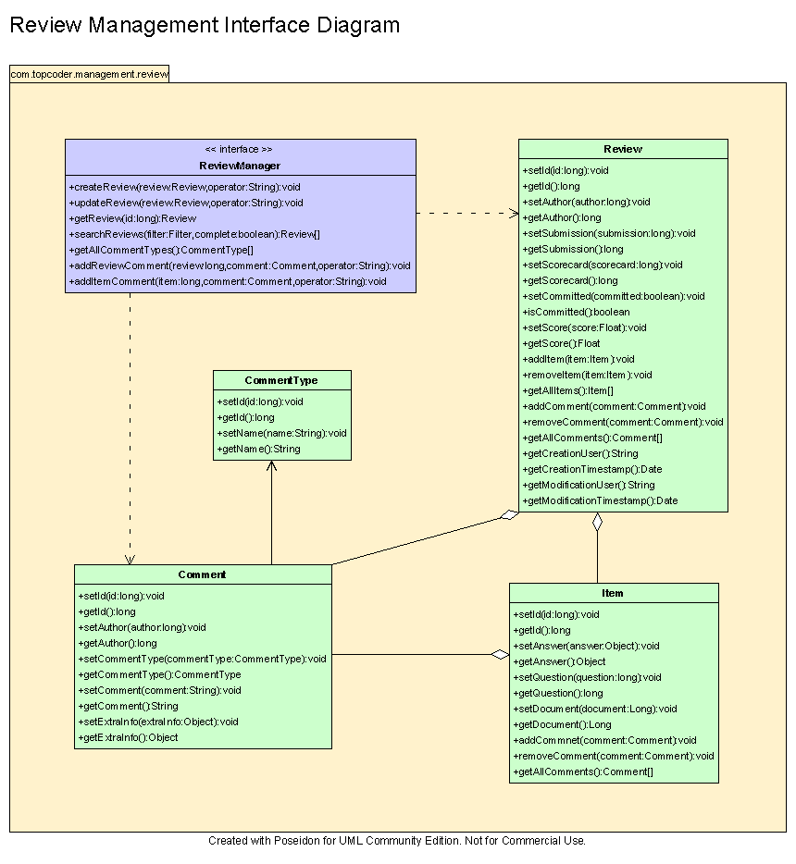

Environment Requirements
- Development language: Java1.4
- Compile target: Java1.4

Package Structure
com.topcoder.management.review

Software Requirements

Administration Requirements

What elements of the application need to be configurable?
- Database connection

Technical Constraints

Are there particular frameworks or standards that are required?
JDBC

TopCoder Software Component Dependencies:
- Configuration Manager
- DB Connection Factory
- ID Generator
- Search Builder

**Please review the TopCoder Software component catalog for existing components that can be used in the design.

Third Party Component, Library, or Product Dependencies:
None.

QA Environment:
- Solaris 7
- RedHat Linux 7.1
- Windows 2000
- Windows 2003
- Informix 10.0

Design Constraints
The component design and development solutions must adhere to the guidelines as outlined in the TopCoder Software Component Guidelines.

Database Connections
Database connections must not be cached within the component. Connections should be created for each operation and closed afterwards.

Component Scalability
The component needs to be scalable. Running multiple instances in the same JVM or in multiple JVM’s concurrently should not cause any problem.

Required Documentation

Design Documentation
- Use-Case Diagram
- Class Diagram
- Sequence Diagram
- Component Specification

Help / User Documentation
- Design documents must clearly define intended component usage in the ‘Documentation’ tab of Poseidon.

